EAGLE LAKE RAINBOW TROUT
Oncorhynchus mykiss aquilarum (Snyder)

Status: Class 1. Threatened listing recommended. Eagle Lake rainbow trout are effectively extinct as a wild fish. Continued reliance on hatchery production for its existence may assure that it will be incapable of becoming re-established as a self-sustaining wild population. Without intervention, it will persist only as a hatchery strain of rainbow trout and even then only as long as the hatcheries are operating.

Description: This subspecies is similar to other rainbow trout in gross morphology (see Moyle 2002), but differs slightly in meristic counts, especially in having finer scales than coastal rainbow trout. It possesses 58 chromosomes rather than the 60 typically present in other rainbow trout (Busack et al. 1980).

Taxonomic Relationships: Snyder (1917) described this trout as a subspecies of rainbow trout, Salmo gairdneri aquilarum. However, Hubbs and Miller (1948) examined Snyder's specimens and concluded that Eagle Lake rainbow trout were derived from hybridization between native Lahontan cutthroat trout and introduced rainbow trout. Miller (1950) later retracted the hybridization theory. Needham and Gard (1959) then suggested that Eagle Lake rainbow trout were descended from introduced or immigrant rainbow trout from the Feather or Pit River drainages. Behnke (1965, 1972) proposed a redband-rainbow hybrid origin, although redband trout are now considered to be rainbow trout subspecies. Busack et al. (1980), in an extensive electrophoretic, karyotypic, and meristic analysis, suggested that Eagle Lake rainbow trout were derived either from immigration or an unrecorded introduction of a rainbow trout with 58 chromosomes. Given the distinctive morphology, ecology, and physiology of this form, it is clear that the Eagle Lake rainbow trout is derived from a natural invasion from the Sacramento drainage. Behnke (2002) speculated that Lahontan cutthroat trout were the original inhabitants of Eagle Lake but they disappeared during the Pleistocene during an extended period of drought. During a wetter period, rainbow trout managed to invade through an unspecified headwater connection (Behnke 2002). Recent genetic studies (ALFP DNA techniques) suggest that the closest relatives of Eagle Lake rainbow trout are rainbow trout from the Feather River (M. Stephens 2007).

Life History: Eagle Lake rainbow trout are late maturing (usually in their third year for females) and were historically long-lived, up to 11 years (McAfee 1966). Trout older than 5 years are rare in the lake today, although individuals as old as 8-9 yrs have been caught (DFG, unpublished data). Originally, the trout spawned primarily Pine Creek, which flows into the lake on the western shore, and, occasionally, in the much smaller Papoose and Merrill creeks, which feed the southern Eagle Lake. Upstream migrations take place in response to high flows in March, April, or May. In Pine Creek, the main spawning areas were presumably the gravel-bottomed spring-fed creeks in the large headwater meadows, such as Bogard Spring Creek and Stephens Meadows, about 45 km from the lake. It is likely that the trout spent at least their first 1-2 years of life in these creeks before migrating to the lake, although it is possible some became stream resident and never migrated . Based on growth of yearling fish from hatchery plantings, they presumably grew to about 40 cm by the end of their first year in the lake, 45-55 cm in the third, and up to 60 cm in the fifth year (McAfee 1966). These fish could apparently reach 3-4 kg and 65-70 cm FL (McAfee 1966). Data from the last 10 years shows that mature females produce an average of 3,300 eggs (Crystal Lake Hatchery CDFG, unpublished data, 2009).
The life history of these fish has been significantly altered because access to spawning grounds in Pine Creek has been obstructed (see below). Today, as fish move up Pine Creek in the spring, they are trapped at a permanent weir installed by CDFG and artificially spawned. The embryos are then taken to Crystal Lake and Darrah Springs hatcheries where they are reared for 14-18 months. The fish that originated from parents captured in the trap are marked and planted in Eagle Lake at 30-40 cm FL (CDFG, unpubl. data). 180,000-200,000 fish are planted in the lake each year, about half in the lake at the mouth of Pine Creek. In addition, up to 10,000 1+kg ‘bonus’ fish may be planted in the fall and spring for the sport fishery.
No fish are allowed to migrate upstream to their natural spawning grounds. All fish are marked to prevent sibling crosses (reduce inbreeding), to avoid using fish that have been more than one generation in the hatchery, and to select for longer lived fish to compensate for longevity reductions that may have been caused by past hatchery practices (R. L. Elliott, CDFG, pers. comm. 1998). Formerly, a captive, domestic strain of Eagle Lake rainbow trout was maintained at the Mt Shasta Hatchery, which was originally planted widely in reservoirs of the state and used as a source for brood stock in other hatcheries in California, as well as elsewhere in the western USA. Eagle Lake rainbow trout are prized because of their delayed maturity, rapid growth, and longevity.
Today, all fish used for hatchery production of Eagle Lake rainbow trout are reportedly first generation fish from the Pine Creek trap, although fish from hatchery broodstock were planted in the lake in the past (P. Devine, CDFG, pers. comm. 2009). The fish planted in waters other than Eagle Lake come from the spawning of individuals derived from Pine Creek spawners and raised to maturity in the hatcheries. Fish planted in Eagle Lake originate directly from fertilized eggs taken from Pine Creek spawners. In the past fish of both origins were planted in the lake, as were Eagle Lake rainbow trout of the domesticated hatchery strain.
Despite this long history of hatchery selection, there is evidence that Eagle Lake rainbow trout can still spawn successfully in Pine Creek. Fish that were trucked to the upper reaches of the creek in the 2000s produced young which survived and grew for two years. A thorough survey of Bogard Spring Creek revealed the presence of at least 170 rainbow trout in 2007, with most fish lengths between 105 and 150 mm FL; in 2008, only 25 ELRT were captured with lengths between 130-165 mm FL (G. Carmona, unpublished data). These fish survived and grew despite the presence of about 5,300 brook trout in the same reach of stream in which they were found (see management section below for details). There is some evidence that the two year old fish will try to migrate downstream to the lake during periods of high spring flow (P. Moyle, unpublished observations, 2006). In spring 2009, an Eagle Lake rainbow trout was captured in Pine Creek at 800 meters downstream from the confluence with Bogard Spring Creek. This fish was fin clipped in September 2008 in Bogard Spring Creek (Moyle and Carmona 2009).
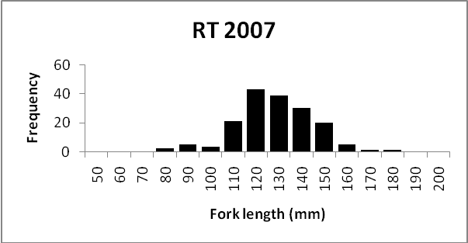

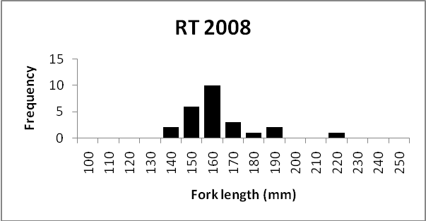
Figure 1. Length frequencies of Eagle Lake rainbow trout captured by electrofishing in Bogard Spring Creek, Lassen County in 2007 and 2008. Courtesy of G Camona, UC Davis.

The diet of the trout varies with age and season. Newly planted trout in their first year in the lake feed mainly on zooplankton, including Daphnia spp. and Leptodora kindti, and on benthic invertebrates, especially leeches and amphipods. By August, most of the trout switch to feeding on young-of-year tui chubs (King 1963, Moyle 2002, Moyle, unpubl. data).

Habitat Requirements: Eagle Lake rainbow trout spend most of their life in Eagle Lake, a large (24 km long by 3-4 km wide), highly alkaline lake. The lake consists of three basins, two of them averaging 5-6 m deep, the third averaging 10-20 m with a maximum depth of about 30 m. The shallow basins are uniform in their limnology and water temperatures may exceed 20°C in the summer. The deep basin stratifies, so in late summer most of the trout are in the deeper, cooler water of this basin. Otherwise, they are found throughout the lake.
Eagle Lake rainbow trout are stream spawners. They formerly migrated over 45 km upstream to spawn in the gravelly upper reaches of Pine Creek and its tributaries. Juveniles then spent their first and/or second year in the stream before moving into the lake during high run-off periods that reconnected headwaters to the lake. During the summer, upper Pine Creek is a cold spring-fed trout stream, flowing at .03-0.14 m³/s through meadows and open forest, with modest gradients. Bogard Spring Creek is also a spring-fed creek, with flows of 0.01-0.02 m³/s. The meadow streams have deep pools and glides with deeply undercut banks, providing lots of cover for trout. The Pine Creek watershed is described in detail by Pustejovsky (2007). Unfortunately, the trout present today in the creek are almost entirely alien brook trout, in high densities (Carmona et al. 2009)).
Environmental tolerances of Eagle Lake rainbow trout are high for a trout and similar to those of coastal rainbow trout. In Eagle Lake, they live in highly alkaline water (pH 8.4-9.6), in which dissolved oxygen is usually at or close to saturation. They have been observed foraging in shallow water at temperatures of 22-23°C but generally retreat to deeper, cooler (<20°C) as lake temperatures increase. The requirements of spawners and juveniles in streams have not been worked out but are presumably similar to those of other rainbow trout (see Moyle 2002).

Distribution: Eagle Lake rainbow trout are endemic to Eagle Lake, Lassen County, and its main tributary, Pine Creek. They have been planted in numerous waters throughout California, where they are maintained from hatchery stocks originating from trout captured at Spaulding fish trap at the mouth of Pine Creek. The trout have also been exported to other states and to Canada. It is unlikely that naturally reproducing populations of genetically ‘pure’ Eagle Lake trout are present in any of these planted waters, although data is largely absent.

Abundance: Naturally spawned Eagle Lake rainbow trout were once abundant in the lake. According to Purdy (1988), "In the spring months of the 1870s and 1880s, when trout were spawning, huge quantities were being caught. It was not unusual to hear that wagon loads of trout, some weighing as much as 600 pounds, were being brought into Susanville where they were sold at local markets for twenty-five cents a pound (p. 14)." This exploitation occurred at the same time as extensive logging in the drainage, heavy grazing in the meadows, and the first construction of railroad grades across the meadows and streams, all of which altered the stream channel. Although commercial fishing for trout was banned in California in 1917, the Eagle Lake rainbow trout populations remained low, presumably because of the poor condition of Pine Creek (and probably Papoose and Merrill creeks as well) and the establishment of predatory largemouth bass and brown bullheads in the lake. During the 1930s, lake levels dropped as the result of diversion of water through the Bly Tunnel and prolonged drought, presumably reduced access of spawning trout to Pine Creek. The high alkalinities brought on by dropping lake levels apparently also eliminated bass from the lake, although bullheads persisted into the 1970s. Even with the return of wetter conditions, the trout populations showed little sign of recovery. In 1950, six trout were captured from Pine Creek and about 2,000 fertilized eggs were taken to Crystal Springs Hatchery. The 600 trout that resulted were used for brood stock (Purdy 1988). Regular trapping operations began in 1959, when 16 trout were captured and spawned; in the next five years the numbers captured varied from 45 to 391 (McAfee 1966). From 1959 through 1994, a few trout were able to make it over the barrier during wet years, allowing a negligible amount of natural spawning (Pustejovsky 2007, Moyle, unpublished data).
At the present time, about 150,000-200,000 trout are planted in the lake each year, all first generation fish derived from adults captured at the at the mouth of Pine Creek; these planted fish support a major sport fishery for "trophy" trout. Hundreds of trout are trapped each year and 1-6 million fertilized eggs per year are taken for hatchery rearing. Thus in 2009, 1,737 females were spawned, producing 5,985,880 eggs, for the hatchery, while in 2008 the take was 2,757,420 eggs, and in 2007, 1,113,980 eggs) (Paul Divine, CDFG, personal communication 2009) There is no evidence of natural reproduction contributing to the lake population; the fish captured by anglers usually show signs of a year or more in a hatchery environment, mainly white snout tips and damaged or missing fins.
Overall, the population appears to be stable because it is maintained entirely by hatchery production, which may be selecting against fish capable of reproducing naturally. While the effects of hatchery rearing on trout populations are sometimes overstated, there is also ample evidence that it does have an impact on the genetics and behavior of fish released into the wild affecting their ability to persist on their own in the wild (e.g., Waples 1999, Araki et al. 2007, 2008, Kostow 2008). Recent evidence suggests that fitness reductions may not just be limited to fish raised in the hatchery but instead continue into subsequent generations (Araki et al. 2009). The continued dependence of the Eagle Lake rainbow trout, on hatchery production assumes that the hatchery program will always be adequately funded and maintained, that a hatchery-dependent population is always going to be desirable, and that restoring the natural life cycle is not a goal worth pursuing.

Nature and Degree of Threats: The factors affecting Eagle Lake rainbow trout fall into five categories: (1) habitat change, (2) diversion, (3) hatchery rearing, (4) exploitation, (5) disease, and (6) alien species (Table 2).
Habitat change. Historically, the greatest single factor causing the near-extinction of Eagle Lake rainbow trout has been the poor condition of the Pine Creek watershed. The watershed was severely altered as the combined result of logging, grazing, and railroad and road building. Besides deforesting large chunks of the watershed and creating erosion-prone roads, 19th and early 20th century logging activity in the region resulted in a railroad being built across the Pine Creek drainage, restricting flow of the creek at one point and channelizing the streambed. This situation worsened when a highway (State 44) was built parallel to the railroad and forced the stream through several culverts. The combination of culverts and channelized stream created a nearly-impassible velocity barrier for the trout. Grazing livestock have been (and continue to be) a major problem because livestock concentrate around the stream (Pustejovsky 2007). In the lower reaches of the stream (Pine Creek Valley, etc.) most of the riparian vegetation is gone and the wet meadows have been so compacted that they have been largely converted into dry flats dominated by sagebrush. As the result of all these activities acting on the stream for nearly 100 years, the lower creek cut down into the former meadow 1-2 m and became more intermittent in flow during summer, with flows diminishing rapidly in the spring. As a consequence, the stream (especially the key spawning and rearing areas above Bogard Campground in Pine Creek and along Bogard Spring Creek have been largely inaccessible to spawning adults . As noted below, many of these problems have been addressed by a multiagency Coordinated Resource Management (CRMP) group and the habitat has been steadily improving (Pustejovsky 2007).
Water diversion. In the past, Eagle Lake was looked upon as a potential source of water for the region around Susanville. This resulted in the construction of Bly Tunnel in the 1920s, to send Eagle Lake water into Willow Creek. This scheme largely failed to deliver the water promised. Nevertheless, Bly Tunnel continues to be a threat to the lake. Although it was blocked off, it still discharges, through an eight inch pipe in the plug, 0.34 cm/s of Eagle Lake water into Willow Creek for downstream water right holders. While some of the water coming from the tunnel may be spring water, most of it is Eagle Lake water because it is chemically nearly identical to Eagle Lake water (Moyle et al. 1991). This is important because in the long run the lake is less likely to become severely alkaline in a prolonged drought if it has more water in it to start with.
While one diversion of water from Pine Creek has been eliminated as part of the CRMP process (it had largely been abandoned anyway), part of the spring flow of tiny Bogard Spring Creek is still being diverted to provide water for a rest stop facility on Highway 44. This water, while small in amount, has the potential to increase the ability of Bogard Spring Creek to support Eagle Lake rainbow trout juveniles.
Hatchery rearing. Eagle Lake rainbow trout are completely dependent on hatchery production for survival (Moyle 2002). If CDFG had not begun trapping these fish in the 1950s, they would now be extinct. Prior to this, they presumably persisted only because occasional wet years permitted access to upstream spawning areas through degraded stream channels and because the fish were exceptionally long-lived for rainbow trout. The danger in the present program is that fish are being selected for survival in the early life history stages in a hatchery environment, rather than in the wild, perhaps for early spawning (as has happened in steelhead, Araki et al. 2007). In addition, fish have been directly selected for large sizes for planting the lake, presumably to increase angling satisfaction (CDFG unpublished). However, sizes of angler-caught fish appear to be fairly static over the years (Figure 2).

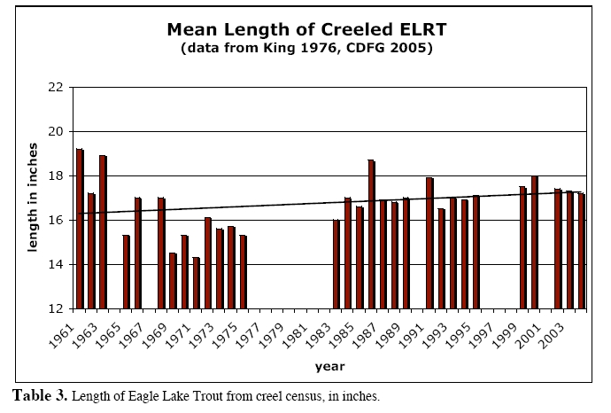
Figure 2. Mean lengths of Eagle Lake rainbow trout caught by anglers, 1961-2005 (from Pustejovsky 2007)

Genetic change has almost certainly occurred as the result of continued hatchery selection, which may reduce the ability of trout planted in the lake to spawn naturally and produce young that can survive in streams. Complete dependence on hatcheries for maintaining the species is undesirable because survival of the species then becomes dependent on vagaries of hatchery funding and management. Survival is further threatened by disease in hatcheries, loss of adaptation for life in the wild, loss of life history diversity, and inbreeding. National Marine Fisheries Service guidelines indicate that a salmonid population dependent on hatchery production cannot be regarded as viable in the long term (McElhaney et al. 2000). The CRMP for Pine Creek (Pustejovsky 2007), if carried out completely, should result in a stream that should be capable of supporting a self-sustaining wild population of Eagle Lake rainbow trout again. However, hatchery production is regarded as being a perpetual necessity in order to sustain the trophy fishery (P. Chappell, CDFG, pers. comm. 1998) and currently it has a higher priority than re-establishment of a wild population.

 | Rating | Explanation
Major dams | N/A
Agriculture | N/A
Grazing | High | This was a major cause of the degradation of Pine Creek watershed; also affects shoreline of lake
Rural development | N/A
Urbanization | N/A
Instream mining | N/A
Mining | N/A
Transportation | Intermediate | Culverts (now fixed) have been barriers to migration but roads continue to affect Pine Creek and lake
Logging | Intermediate | Major activity in watershed
Fire | Intermediate | Has potential to negatively impact Pine Creek and watershed
Recreation | High | Demand for recreational fishery is major reason for not allowing fish to spawn naturally. Fishing in Pine Creek could disrupt restoration
Harvest | Intermediate | Major problem in past
Hatcheries | High | All fish produced in hatchery for 60+ years
Alien species | High | Brook trout in Pine Creek major barrier to restoration. Alien diseases a threat
Table 1. Major anthropogenic factors limiting, or potentially limiting viability of the Eagle Lake rainbow trout population in California, where a factor rated “high” is major limiting factor, a factor rated “intermediate” is a factor that has the potential to be a major limiting factor but has only a moderate effect so far on population viability, and a factor rated “low” has a low or unknown effect on population viability. Certainty of these judgments is high.

Exploitation. As indicated above, in the 19th century, Eagle Lake rainbow trout were once heavily exploited by a commercial fishery, which probably contributed to its initial decline. Since the 1950s, however, demand for the trout in the lake sport fishery has been the principal reason its population has been maintained by hatchery production. There is concern that if too many spawners are allowed to run wild, hatchery production will decrease, resulting in fewer trout be planted in the lake. This is despite the fact that a high percentage of the production today is planted in places other than Eagle Lake and that the actual carrying capacity of the lake for rainbow trout is not known. It may be that planting fewer fish would result in higher survival rates of the planted fish and more rapid growth rates. If a run becomes re-established in Pine Creek, the trout fishery in the creek will have to be managed in ways that do not effect recruitment to the lake.

Alien species. Many different species have been introduced into Eagle Lake in the past, but none have persisted because of the lake's alkalinity. However, because of Eagle Lake's large size and accessibility, it is likely that other species will be introduced illegally and eventually one may succeed, altering the ecology of the lake. Ironically, introduced species are most likely to become a problem if lake levels rise and alkalinity decreases, as happened in the early 1900s, when largemouth bass and brown bullhead became abundant in the lake (see above). The only alien species in the drainage now is brook trout, which is abundant in Pine Creek. Predation and competition by brook trout in Pine Creek may prevent reestablishment of Eagle Lake rainbow trout, so a program to eliminate this species from the watershed is needed. . The high densities and biomass of brook trout in upper Pine Creek indicates high potential for rearing Eagle Lake rainbow trout in large numbers in absence of brook trout (Carmona and Moyle 2009) with considerable potential for maintaining large populations in the lake with natural spawning.
Disease. A continual threat to the survival of Eagle Lake rainbow trout is exotic diseases, either in the hatcheries in which they are reared or by introduction into the lake by hatchery-reared fish, causing the elimination of most ELRT stock through a disease epidemic.

Effects of Climate Change: Climate change is likely to have two major impacts on the Eagle Lake watershed: decreasing stream flows and changing lake conditions. Reduced snowpack in the mountains in the Pine Creek watershed will presumably reduce spring outflows, needed for spawning, and the output of springs that feed Pine Creek. The size of this effect, however, will depend on the timing of rainfall and how well meadows are managed to increase their ability to hold water and release it during the summer months. Reduced inflow into the lake could potentially increase alkalinities to lethal levels for trout, although if average precipitation remains roughly the same, the lake should maintain itself. Surface temperatures of the lake could potentially increase 2-3°C but presumably there would continue to be a cold water refuge for trout in the deepest basin of the lake.

Status Determination. Score = 1. Eagle Lake rainbow trout are likely to go extinct as even a potential wild fish in the next 50 years or sooner if present trends continue, absent successful actions to restore a naturally spawning population (Table 2). Extinction will occur because continued hatchery selection is likely to select against the ability of the fish to maintain a natural life history and/or because of elimination of hatchery stock through a disease epidemic. The Eagle Lake rainbow trout is not formally listed by either state or federal governments. A petition for listing it as a threatened species was rejected by the USFWS in 1994 (Federal Register 60 (151):401: 49-40150, August 7, 1994). A similar petition was rejected by the State Fish and Game Commission in 2004. In both cases, there was insufficient information presented. The Eagle Lake rainbow trout is currently regarded as a Species of Special Concern and a Heritage and Wild Trout Program by the California Department of Fish and Game and as an R5 Sensitive Species by USFS. The American Fisheries Society lists it as a threatened species, while NatureServe lists it as “critically imperiled” (Jelks et al. 2008). The status score could easily be a ‘1’ because it is effectively extinct as a wild fish today and that continued reliance on hatchery production for its existence may assure that it will be incapable of becoming re-established as a self-sustaining wild population.

Metric | Score | Justification
Area occupied | 1 | Only one watershed
Effective population size | 1 | If only hatchery fish were included the score would be 4.
Intervention dependence | 1 | Persistence depends on trapping fish for hatchery spawning and rearing.
Tolerance | 4 | One of most tolerant, long-lived kinds of trout
Genetic risk | 1 | Hatchery rearing presumably has changed genetics; accidental hybridization in hatcheries possible
Climate change | 1 | Reduced stream flows or increased alkalinity of lake could endanger fish further.
Threats analysis | 1 | See Table 1
Score | 1.4 | 10/7
Certainty (1-4) | 3 | Well documented although limited peer reviewed literature
Table 2. Metrics for determining the status of Eagle Lake rainbow trout, where 1 is a major negative factor contributing to status, 5 is factor with no or positive effects on status, and 2-4 are intermediate values. See Introduction for further explanation.

Management Recommendations: The most important step in the management of Eagle Lake rainbow trout is to make restoration of a wild, naturally-spawning population a higher priority than maximizing egg ‘take’ for hatchery reproduction. There is no reason to think that a substantial take of eggs for hatchery purposes could not take place even if 10-20% of the adult fish were diverted for natural spawning and for experimental migration studies, especially because hundreds of thousands of fertilized eggs and fish are sent to other hatcheries to rear and to stock in waters other than Eagle Lake. Given that Eagle Lake rainbow trout have gone through more than 60 years of selection for reproduction and survival under hatchery conditions for a significant part of their life cycle, it is imperative to start reversing that process as soon as possible. This has long been recognized, resulting in formation of the CRMP group in 1987, followed by many projects on the creek to improve flow and remove passage barriers (Pustejovsky 2007). It is likely that initially a program of trapping and trucking adults and juveniles past low-flow parts of the creek will be necessary. A recent research study has demonstrated that trapping and trucking is a viable option for helping to recreate a naturally reproducing population; the study suggests that if the trout had been allowed to go upstream naturally early in the season they could have spawned successfully and perhaps emigrated back to the lake as well following spawning (Moyle and Carmona 2009). The costs would presumably be comparable to costs of rearing hatchery fish but with fewer genetic consequences (e.g., Waples 1999, Araki et al. 2007, Kostow 2008).
Such a program will take considerable resources, although less than a hatchery. The presence of such a program would provide additional incentive to improve flows in the lower reaches of the creek, into May and June. There is already evidence that Eagle Lake rainbow trout, at least during wet years, can make it up to the spawning areas and spawn successfully. In the 1980s, a few juvenile rainbow trout were found below Stephens Meadow; suggesting adults made it over the weir and migrated upstream (Moyle, unpublished data). In 1999-2005, biologists from DFG, USFS and U C Davis placed radio transmitters in a small number of adult fish which were released above the mouth weir (L. Thompson, UC Davis, pers. comm.). In 1999, one of these fish apparently made it into the Pine Creek headwaters, as its transmitter was recovered in Bogard Springs Creek, a tributary to Pine Creek above the highway (T. Pustejovsky, pers. comm.). In 2002-2006, Paul Chappell of DFG released a few ripe trout from the fish trap at the mouth of Pine creek above highway 40.
In September 2006, a crew from UC Davis, DFG, and USFS sampled Pine Creek to look for Eagle Lake rainbow trout (Moyle, unpublished data). They found evidence that the trout had spawned successfully in the creek in the past two years, because small numbers of young were found at several locations in Pine Creek. About 100 m of Bogard Spring Creek were electrofished and 10 juvenile rainbow trout (76-90 mm FL) were captured along with about 170 brook trout or varying sizes. Presumably the rainbow trout were YOY or yearlings. The rainbow trout tended to be in faster water than the brook trout, in reaches with deep overhanging cover. The UC Davis crew also found 3-4 small rainbows in Pine Creek below the Bogard Spring Creek confluence, as well as a couple of rainbow trout in the 145 mm range living in a creek filled with brook trout of all sizes, speckled dace, Lahontan redside, and Tahoe sucker. Curiously, several of the large trout from the lake that had been planted in the spring were still surviving in the pool below the culvert under Highway 44. Likewise, three spawners were found alive in a culvert about 5 km below the highway, in a largely dry stream (no flow), along with a rainbow trout that was 142 mm SL.
In 2007 at least 10 large ELRT (40-50 cm FL) were found downstream from the gauging station weir on Pine Creek (G. Carmona, pers. comm.).
In, 2007 and 2008, the entire length of Bogard Spring Creek was electrofished to remove brook trout to see if spawning success of transplanted adult rainbow trout could be increased and assess whether a three-pass electrofishing removal can successfully depress brook trout populations. Approximately 6500 brook trout were removed from the 3 km long creek (ca. 2000 fish /km), which is remarkable considering the creek is less than 1 meter wide for all of its length and mostly less than 40 cm deep. During 2007, 170 juvenile Eagle Lake rainbow trout were captured and returned to the creek; most fish were under 150mm FL which indicates that they were not hatchery fish planted in the stream by DFG at larger sizes (G. Carmona, unpublished data) This evidence strongly indicates that a wild spawning population of Eagle Lake rainbow trout can be reestablished through translocation.
Because of the interest in Eagle Lake rainbow trout, major efforts have been made in recent years to fix the passage problems in Pine Creek, through the CRMP process (Pustejovsky 2007). As a result large sections of the creek have been fenced to keep out livestock, off-creek watering stations have been provided, an impassible culvert under Highway 44 has been replaced with a passable one, and a structure to divert water in from Pine Creek near the Bogard Campground has been removed (and the meadow fenced). However, the meadows along the lower Pine Creek and Bogard Spring Creek are still grazed by cattle and the creek below Highway 44 is generally dry by May or June.
With this information in mind, elements of a conservation strategy for the trout should include:
- Make restoration of a wild, naturally-spawning ELRT population a higher priority than maximizing egg ‘take’ for hatchery production
- Make the permanent weir at the mouth of Pine Creek a temporary barrier, allowing part of population to move upstream for spawning.
- Starting immediately, release early-spawning adults into the creek above the weir, to maximize potential for natural migration and spawning. This should be the highest priority for the use of trout captured at the Pine Creek weir.
- Establish an annual trapping and trucking operation for both adults and out-migrating juveniles until there are signs the population is self-sustaining and habitat has improved.
- Continue habitat improvements to Pine Creek with the goal to ultimately turn it back into a stream that flows well into the summer for more of its length, following the recommendations in Pustejovsky (2007). A key is reducing grazing and other impacts.
- Develop Bogard Spring Creek into an experimental spawning stream by constructing a weir/trap at the lower end and then eradicating brook trout through electrofishing and other means.
- Increase the flows of Bogard Spring Creek by eliminating the diversion that provides water to the rest station on Highway 44.
- Conduct annual monitoring of fish populations in the creek to determine spawning success, as well as monitoring habitat conditions..
- Reduce livestock use of meadows even further and fence the entire length of Pine Creek.
- Develop an eradication strategy for brook trout in Pine Creek using either piscicides or other means. A first step is to conduct a thorough investigation of the aquatic insect fauna of the creek to determine potential impacts of piscicides on the insects.
- Acquire the water rights to Eagle Lake water now being diverted through Bly Tunnel and shut off the flows completely, at least during times of drought when lake levels are dropping.
- Determine the feasibility of using Papoose Creek for establishment of a small spawning population.
- Conduct a thorough study of the survival and growth trout planted in Eagle Lake, to determine its actual carrying capacity for the trout. Planting of trout in the lake (150,000+ per year) seems to be based more on availability than on any scientific information. It is possible that planting fewer trout may actually improve trophy angling.

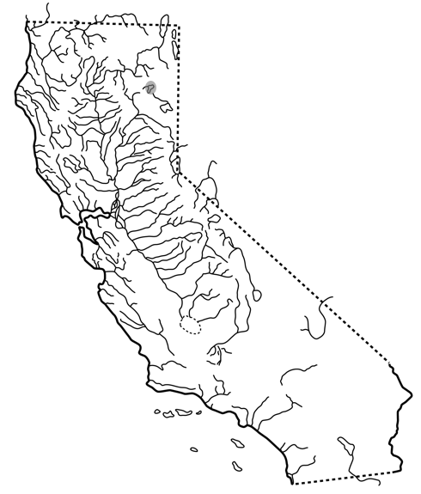

FIGURE X. Distribution of Eagle Lake rainbow trout, Oncorhynchus mykiss aquilarum, in Eagle Lake, California.

This account is updated from Moyle, Israel, and Purdy (2008), which in turn was based on Moyle et al. (1995)

